DEPLOYING WEBSITE IN AWS S3
STEP 1:
In your AWS management console ,after signing in you will see all the services provided by them. Use the S3 service for creating bucket. Click on ‘Create bucket’

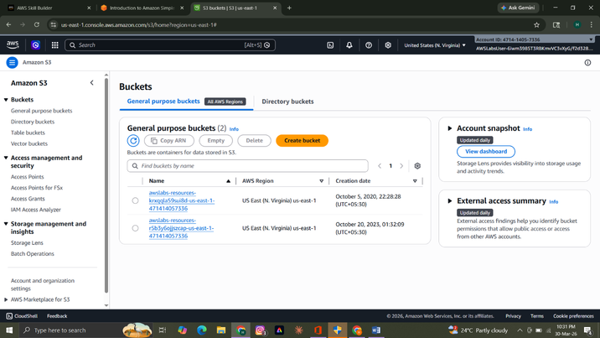

STEP 2:
ACL stands for access control list. After clicking on ‘create bucket’ you are only suppose to configure the required settings. Use a unique name for your bucket and select a region . For a public bucket use the following settings shows in the screen shot. After that click on ‘Create bucket’ and your bucket would be created.

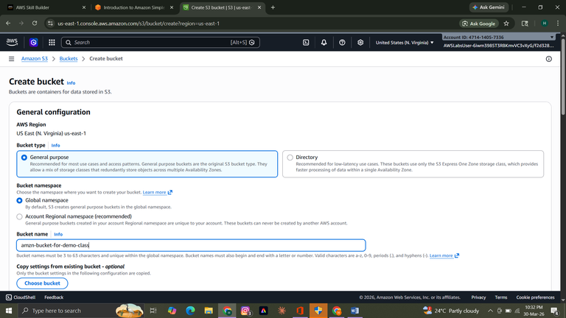

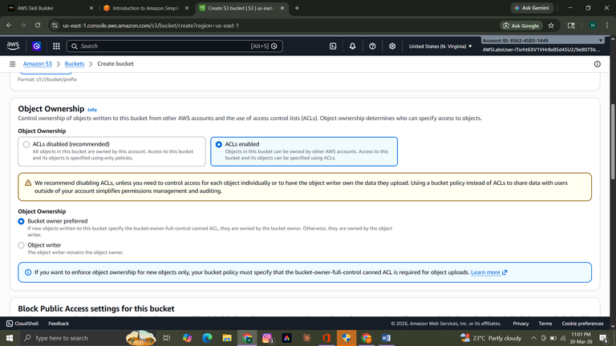
(Enable ACL for keeping it public)

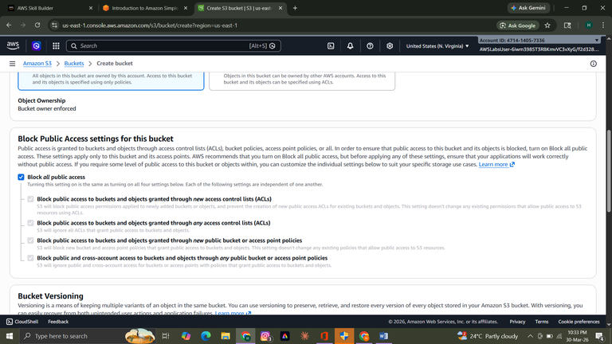

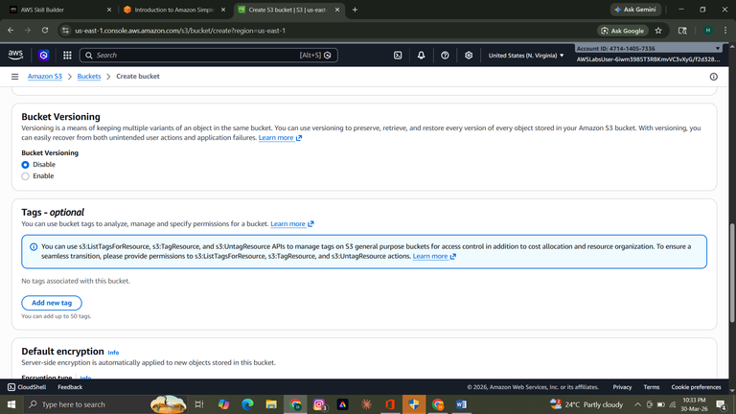

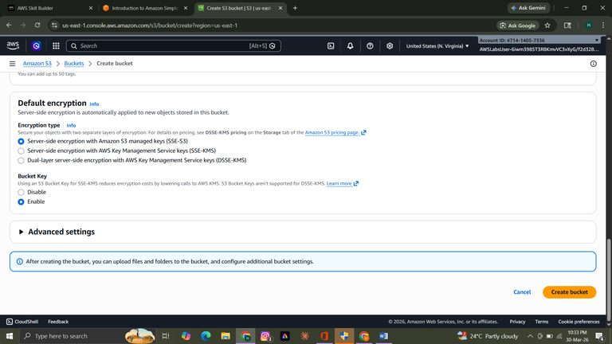

STEP 3:
Upload your website file in S3 bucket you created.

STEP 4:
Go to your S3 dashboard and select your bucket , actions>Make public using ACL . This will make your file public and anyone can open it using url. Confirm the public access

